Educational Scholarship Paper Guidelines
Notes:
• MSSE educational scholarship papers must not contain any information that could be used to identify your school, classroom, etc. Use generic terms like primary, elementary, middle, or high school level when describing what you teach. There can be no identifying demographics, but information like the name of the city/state where you live is acceptable. Student educational records are not allowed. You can create assessments and use them for validation purposes, but data cannot be included in your paper.
• These papers will be archived on the MSSE website and labeled as Instructional Resources available for teachers.
Refer to all MSSE/MSU guidelines posted on the MSSE Capstone Guidelines page. Make the following modifications for educational scholarship papers.
- Chapter 1 = Introduction and Background
  - Level 1 heading: Context of the topic, clearly identifying the focus topic for the paper
- Chapter 2 = Conceptual Framework
  - Level 1 headings: Up to 5 headings based on the theme titles from the literature that provide the underpinnings of the topic
- Chapter 3 = Instructional Strategies
  - Use appropriate Level 1 headings as needed
  - The goal of this chapter is to present instructional materials you have created. The intended audience are science educators who can implement your instructional strategies in their educational context.
  - Create a multi-lesson unit of study based on the chosen topic, creating at least five 5E lesson plans with corresponding assessments. The lesson plans must follow the MSSE 5E lesson plan template (Appendix A). Use the example lesson plan to guide your work (Appendix B). You could also create a Storyline for your topic. That would also include 5 E lessons. Tools for creating and using Storylines are available from NSTA.
  - Depending on your instructional strategies, consider whether these are best placed in an Appendix or included as part of the narrative.

      - Chapter 4 = Value: Reasoning and Reflection
- Level 1 heading: Guidance for Implementation
- Reflect on the following questions:
  - What foundational knowledge should students have before engaging with these resources?
  - How can the sequence of instruction be structured for optimal learning, considering what come before and after these resources?
  - What are the most effective strategies for using the assessments included in these resources?
  - Are there opportunities to expand upon the material provided in these resources?
- Level 1 heading: Professional Development
- Reflect on the following:
  - How have you changed as a practitioner during this process?
  - What insights have you gained and how have they transformed your teaching practices?

APPENDIX A:

MSSE 5 E LESSON PLAN

5 E LESSON PLAN MODEL SUGGESTION
If you are writing for a science content course, list the specific science content you are addressing in a bulleted list. For education courses, you don’t need the science content listed.
Science Content
Then weave the science content into the 5 E stages so that it’s clear to the reader.
Engage
Explore
Explain
Elaborate
Evaluate
Include a page in the appendix that addressed the science & engineering practices and crosscutting concepts (Appendix A).
If figures or tables are used, be sure to format according to the guidelines in the template resources.

APPENDIX A:

SCIENCE & ENGINEERING PRACTICE & CROSSCUTTING CONCEPTS TABLE
Connecting to the Next Generation Science Standards (NGSS Lead States, 2013)
This is an EXAMPLE. Delete and include the DCIs, SEPs, and CCCs used for your lesson plan
5-PS1-3: Matter and Its Interactions
www.nextgenscience.org/pe/5-ps1-3-matter-and-its-interactions
The chart below makes one set of connections between the instruction outlined in this article and the NGSS. Other valid connections are likely; however, space restriction prevent listing all possibilities. The materials, lessons and activities in the article are just one step toward reaching the performance expectations listed below

Lesson Component | NGSS Connection | Connections to Classroom Activity, Students:
Performance Expectation | 5-PS1-3: Make observations and measurements to identify materials based on their properties | - are introduced to the properties of water, including adhesion, cohesion, surface tension
Science and Engineering Practices | Asking Questions and Defining Problems | - observe the phenomenon of a water strider standing on the surface of the water and ask questions  - observe other supporting phenomena and ask questions
 | Engaging in Argument from Evidence | - make claims, provide evidence and state their reasoning to explain the phenomena (2-PS1-4)
Disciplinary Core Idea | PS1-A: Structure and Properties of Matter | - different properties are suited to different purposes
Crosscutting Concepts | Cause and Effect | - make sense of causes that generate observable patterns (2-PS1-1)  - conduct simple tests can be designed to gather evidence to support or refute student ideas about causes (2-PS1-2)
Connections to Nature of Science | Science searches for cause and effect relationships to explain natural events | - observe and make sense of natural events (2-PS1-4)

APPENDIX B

5 E LESSON PLAN EXAMPLE

5E AND INQUIRY LESSON PLAN
Unit Topic: Cell Energy and Metabolism

Lesson Science Content: Cell Respiration/Fermentation

Length: 50 minutes

Performance Expectation: Use a model to illustrate that cell respiration is a chemical process whereby the bonds in the new compounds are formed, resulting in the net transfer of energy.

Materials Needed:
Teacher: Mason Jar, 50 grams Magic Dough (See Appendix for Recipe), 75 grams Purpose Flour, 75 grams lukewarm H2O. Magic Dough video. Ending video:

Student Materials: 7 packs of dry active yeast packets, Table sugar grams, 7 250 mL beakers, 7 disposable pipettes, 7 Whiteboards, Whiteboard Markers, Science Notebooks, Projection Technology to display video and the Mason Jar phenomenon.

Background: Sourdough bread starters have been used for 1000s of years to cultivate yeast on naturally harvested grains. The yeast “captured” in these natural bread starters can be used to make naturally rising breads such as those found in sourdough. These wild yeasts are often of the variety Saccharomyces Cerevisiae, commonly known as Baker’s Yeast. Yeasts serve as a model organism to study the process of Cellular Respiration and Anaerobic Fermentation, making them a welcome starting point in a unit covering Cell Energy and Respiration.

NGSS DCI, SEPs & CCCs: Appendix A

Engage
Opening: This lesson is designed to be the opening of a unit focused on Cell Energy. Specifically, the topics of metabolism, respiration, and fermentation. The core idea covered in this lesson is Organization of Matter and Energy Flow in Organisms. As students enter class, the teacher will present a mason jar containing 50g of Magic Dough to students for the anchoring phenomenon of the unit. Students will not be told what it is in the Magic Dough, just that it contains a mixture of water and flour that has been sitting in the mason jar for about a week. Teacher Note: the Magic Dough should be made 6 days prior to the lesson, following the recipe for maximal yeast cultivation (Appendix B). Also, since the Magic Dough is a type of cultivated yeast starter, yeast activity depends on a range of environmental conditions such as temperature and humidity, which could elicit variable responses for your anchoring phenomenon demo. Teachers should elicit student experiences with the following questions (5 minutes).
- Where in the world have you encountered mixtures of flour and water before?
- Are water and flour classified as living organisms?

As you are having this conversation on the phenomenon, add your 75 grams of warm water (approx. 98 degrees for optimal yeast activity) and 75 grams of All Purpose Flour to your Magic Dough. Stir to combine. Tell students to record observations about the phenomena in their notebooks using all five senses (5 minutes).
Potential Observations: Smells Sour, bubbles forming, foamy top, liquid at the top of the mason jar, air pockets inside the dough. After students are done with recording their initial observations, the Magic Dough starters should already start to increase in volume in the jar and give off a gas. If the Magic Dough being used isn’t increasing in volume in the jar, show the following video. This will show students how the magic dough rises in volume over time.
Explanation of Phenomenon: The wild Baker’s Yeast (Saccharomyces cerevisiae) in the Magic dough took the starch in the flour, started breaking into glucose, and produced CO₂ as a byproduct of Cellular Respiration. Some ethanol was made as a byproduct of Fermentation, giving the sour smell. Both processes can occur simultaneously.)Understanding this phenomenon fully requires the Core Idea of Organization of Matter and Energy Flow. New matter (CO₂ gas + Ethanol) came from existing matter (Flour & Water) in the Magic Dough Phenomenon. As the yeast metabolized the flour and made new molecules, energy was transferred/ used for growth.

Explore
Debrief with students on the results of the video and/or the class Magic Dough Phenomenon (Appendix B). Consensus observations should include: the dough has risen, a new smell was produced, and bubbles have formed (5 minutes).
Revisit the question: Was the Magic Dough system a living thing? At this point, most students will respond yes. Discuss another item that could have been in the dough to cause it to rise. Students will draw on their past experiences with baked goods and/or bread to hypothesize perhaps there was yeast or another leavening agent in the Magic Dough. Describe to students that yeast can be found on flour, is a living organism much like humans, and depends on food for energy as a consumer.
Let students investigate how yeast functions. Divide students into 7 lab groups. Each group will need 1 pack of instant quick rise yeast, 75 grams of lukewarm water (from sink is ok), and a chosen amount of sugar no greater than 20 grams. Have one group be the 0 grams sugar (control). Combine sugar, yeast, and water into the 250 mL beaker. Have students record their observations of the yeast + water + sugar mixture in their science notebooks. Students should see that the mixture in beaker bubbles like the magic dough, produces a gas, and rises in volume (15 minutes).

Explain
After students made observations and recorded questions about the Magic Dough Phenomenon in their Science Notebooks, and using their personal yeast investigations as a guide, have students whiteboard what they think the yeast were doing in the Magic Dough phenomena on whiteboards as a group. Tell students to represent the flour, yeast, water, and gas by using simple shapes such triangles, circles, and squares. Be sure to include a before picture when the flour was first added and an after picture when the gas was being produced. Allow students to do a quick gallery walk once their boards are done to see other groups’ work. Have students take a picture of their group’s whiteboard and submit it to your Learning Management Site when done (10-15 minutes).
Closing: When done whiteboarding, watch the Yeast Fermentation under Microscope video: until the 2:00 mark. Discuss the source of sugar in both the opening phenomenon (the flour added) and their experiment. Have a concluding discussion on how it may be possible to manipulate yeast mixtures and the magic dough to get it to produce more gas from the sugar, rise faster, and acquire energy to grow over time Also, revisit the Magic Dough opening phenomena. Note any changes that are seen in the mason jar since the start of the period. Record these ideas in a new section of the students’ science notebooks (5 min).
Note: The more specific details of cell respiration and fermentation are expected to be covered in the next series of lessons within this unit, allowing the anchor phenomenon to be fully explained.

Evaluate
During this lesson, the teacher will visit lab groups around the room when while students are discussing. The teacher should be asking probing questions to keep students on task and challenge them to apply concepts as well as scientific vocabulary learned in previous lessons. To promote crosstalk, the teacher should redirect some questions directed to the instructor to another member in the lab group so that they share knowledge with one another.
The day after this lesson, students will complete a claim, evidence, reasoning statement (CER) to evaluate their understanding on the products of the Magic Dough Phenomenon (Appendix C). This CER will extend the students’ understanding of this phenomenon to another area: baking and brewing with yeast. Students will use observations collected in the Day 1 Anchoring Phenomenon lesson to evaluate the potential differences in Baker’s and Brewer’s yeast and engage in argumentation with evidence to hypothesize which variety of yeast was found in the Magic Dough. This leads well into a discussion of the products of Fermentation and Cellular Respiration to further extend the explain domain of the 5E lesson model.
Students will complete a summative assessment for the overarching unit once the full details of the anchoring phenomenon are covered in class.

Extend
In the next series of lessons, students will be tasked with investigating the variables that speed up or slow down yeast growth, now that they are aware of the necessary components to activate the Magic Dough and the yeast’s growth (flour, sugar, H2O). Due to the nature of yeast energy production, students may recognize an alcoholic scent being produced from their yeast mixtures. This indeed is the byproduct of fermentation: ethanol. Further lessons can dive into the differences between Brewer’s Yeast (S. pombe) and Baker’s Yeast (S. cerevisiae).
This lesson provides direct connections to students taking classes in or interested in the culinary arts. As leavening agents such as yeast are often used to make students’ favorite foods, students are more likely to be engaged with a relatable phenomenon. Likewise, many cultures consume fermented foods and/or foods that contain yeast, further providing real world connections as suggested by the 5E model.

APPENDICES

APPENDIX A:

SEPs & CROSSCUTTING CONCEPTS TABLE

HS-LS1-7 From Molecules to Organisms: Structures and Processes
https://www.nextgenscience.org/pe/hs-ls1-7-molecules-organisms-structures-and-processes
The chart below makes one set of connections between the instruction outlined in this lesson and the NGSS. Other valid connections are likely; however, space restriction prevent listing all possibilities. The materials and this lesson are the just start towards mastery of standards below.

Lesson Component | NGSS Connection | Connections to Classroom Activity, Students:
Performance Expectation | HS-LS1-7: Use a model to illustrate that cell respiration is a chemical process whereby the bonds in the new compounds are formed, resulting in the net transfer of energy. | - Students make initial models to how the magic dough is consuming food, growing, and harvesting energy from the flour.
Science and Engineering Practices | Asking Questions and Defining Problems | - observe the phenomenon of a “magic dough” consuming flour and using it to create gas, other matter, and grow in volume over a class period.  - Ask questions about on phenomenon
 | Developing and using Models | - make claims based on evidence to construct explanations of phenomena.
 | Engaging in Argument from Evidence | - See CER Below in Appendix B
 | Obtaining, Evaluating, and Communicate Info | - Develop Questions from Initial Phenomena  - Full class/lab group discussions  - Video on Yeast/Respiration
Disciplinary Core Idea | LS1.C: Organization for Matter and Energy Flow in Organisms | - New products (matter) are made from existing matter as yeast/magic dough grows/respires.  - Energy is transferred as molecules are broken and new ones are made.
Crosscutting Concepts | Cause and Effect | - If food is added to the magic dough/yeast, the organism responds by growing. Lack of food = less growth
 | Energy and Matter | - Energy is not created nor destroyed. The food added to Magic Dough does not disappear, rather turns into a new form.
Connections to Nature of Science | Science searches for cause-and-effect relationships to explain natural events.  Hypotheses are revised as new evidence is collected and obtained.  Science is a creative process. | - Flour/sugar amount affect magic dough.  - Students’ initial models and final models of the phenomenon will inevitably differ.  - Student groups will likely interpret the magic dough phenomenon differently

APPENDIX B:

MAGIC DOUGH RECIPE and MAGIC DOUGH SETUP

Magic Dough Recipe
You will Need:
¾ L Mason Jar (Use this one)
To create the Magic Dough: Add on Day 1:
60 grams of whole wheat flour
60 grams of tap water
Stir to combine. Let the mason jar sit at room temperature.
“Feed” the starter each day by adding the following to your mason Jar (Days 2-7)
60 grams unbleached all-purpose flour
60 grams of water.
Mix completely and stir to combine. Let the mason jar sit at room temperature.
*Note: Based on my experience and research, use unbleached flour to get maximal yeast populations in your flour mixture*

Magic Dough Phenomenon Setup:
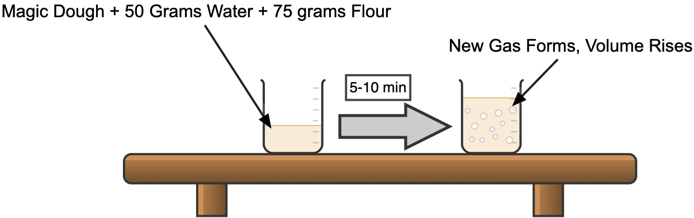

APPENDIX C:

STUDENT CER FOR ASSESMENT

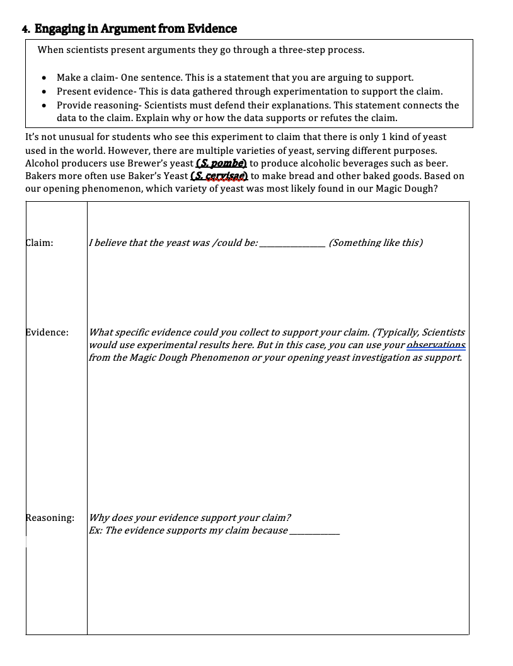

Adapted from an assignment submitted by Matthew Hopkins, 2023

